Preliminary report of M_{w}7.3 Sarpol-e Zahab,
Iran earthquake on November 12, 2017
Mehdi Zare
Professor of Engineering Seismology, International Institute of Earthquake Engineering and Seismology (IIEES), and Associate member of Academy of Sciences of Iran. e-mail: mzare@iiees.ac.ir
Farnaz Kamranzad
Ph.D Student of Mineral Exploration Engineering, Department of Mining Engineering, College of Engineering, University of Tehran. e-mail: f_kamranzad@ut.ac.ir
Issaak Parcharidis
Associate Professor of Space based Earth Observation Applications, Harokopio University of Athens, Department of Geography
Varvara Tsironi
Msc in Msc in Dynamic, Tectonic and Applied Geology

2017 Sarepol-e Zahab Iran earthquake
On November 12, 2017, at 18:18 UTC (21:48 Iran Standard Time), a major earthquake with the moment magnitude of 7.3 occurred in Kermanshah province of Iran. According to the National Center of Broadband Seismic Network of Iran, the epicenter of this event was located at 34.88°N and 45.84°E near the Iran–Iraq border with a depth of 23 km. The epicenter has a distance of about 5 km to the town of Ezgeleh (Fig 1), 43 km from Sarapul-e Zahab city and 46 km from Qasr-e-Shirin city. The focal mechanism solutions for this earthquake indicate a fault dipping shallowly to the east-northeast, or on a fault dipping steeply to the southwest. Based on the active fault map of Iran, this earthquake can be triggered by the movement of the Zagros Mountain Front Fault (MFF) in Pol-e-Zahab Region.
This event that continued for 30 seconds, was felt in an extended area in Iran, Mesopotamia, the Caucasus, eastern Turkey, Iraq and Syria. Until November 20, 2017 (8:00 a.m. UTC time), about 460 aftershocks with magnitudes over 2.5 have been recorded by the Iranian Seismological Center (IRSC) (Fig 2). The largest magnitude of this earthquake's aftershock sequence was 4.7, which occurred November 13th.

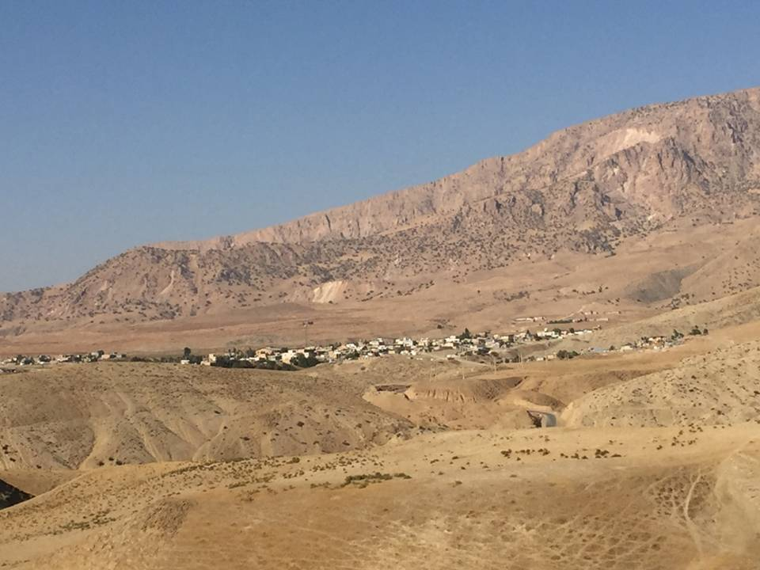
Fig 1. Ezgeleh, the nearest town to the epicenter of the 2017 Sarpol-e Zahab, Iran earthquake

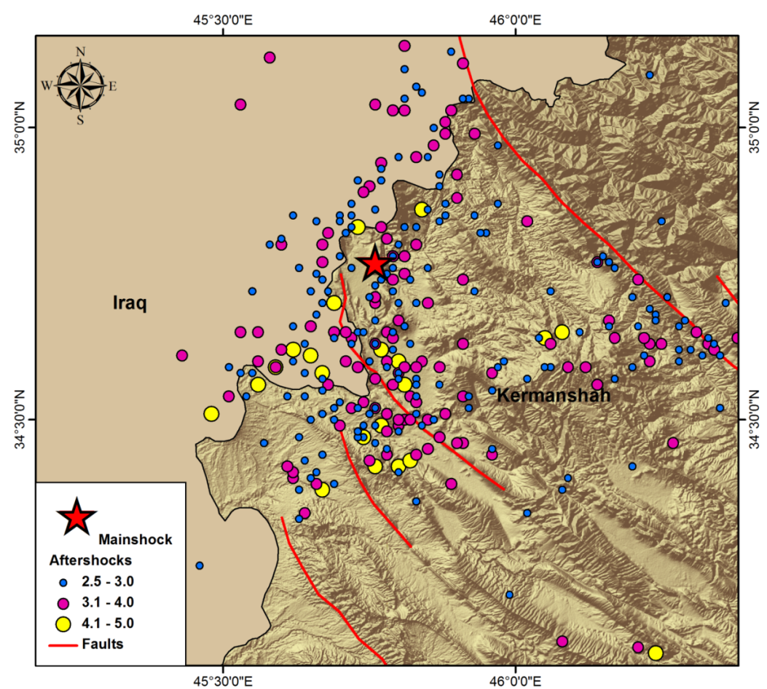
Fig 2. Aftershocks of the 2017 2017 Sarpol-e Zahab, Iran earthquake.
Strong Motion and Intensity
The strong motion of the November 12, 2017, M_{w}7.3 mainshock has been recorded by 98 stations of the Iran Strong Motion Network (ISMN) (Table 1). Among these records, the highest value corresponds to the Sarepol-e Zahab station with an uncorrected PGA of about 684 cm/s² (Fig 3). The corrected PGA values of the important records will be soon released in subsequent studies.

Table 1. Strong motion records of the 2017 Iran-Iraq earthqauke
No | Station Name | Record No | Un. PGA (cm/s²) | Epicentral Distance | Station Code
1 | Sarpolezahab | 7384/01 | 684 | 39 | SPZ
2 | Goorsefid | 7377/01 | 309 | 66 | GRS
3 | Kerend | 7302/01 | 261 | 66 | KRD
4 | Loomar | 7385 | 139 | 161 | LUM
5 | Eslamabadqarb | 7313 | 123 | 96 | ELA
6 | Ravansar | 7296 | 120 | 70 | RVN
7 | Homail | 7294 | 93 | 125 | HML
8 | Arkvaz-e-MalekShahi | 7378 | 91 | 170 | AVZ
9 | Shoeisheh | 7317 | 88 | 93 | KAT
10 | Mahidasht | 7295 | 86 | 101 | MHD
11 | Dinevar1 | 7304 | 81 | 143 | DIN1
12 | Marivan | 7287 | 70 | 83 | MAR
13 | Degaga | 7310 | 70 | 67 | DGG
14 | Ilam1 | 7341 | 69 | 138 | ILA1
15 | Badreh | 7315 | 64 | 197 | BDR
16 | Soomar | 7375 | 61 | 106 | SUM
17 | Kermanshah1 | 7292 | 55 | 120 | KRM1
18 | Lenjab | 7376/01 | 55 | 125 | LJA
19 | Sarv Abad | 7290 | 54 | 70 | SVA
20 | Nosood | 7297 | 53 | 47 | NSD
21 | Palangan | 7279 | 50 | 70 | PAG
22 | Sahne | 7303 | 45 | 166 | SHN
23 | SarDasht | 7289 | 40 | 155 | SRS
24 | Firoozan | 7284 | 36 | 208 | FRA
25 | Kamyaran | 7278 | 35 | 93 | KYN
26 | Aran | 7301 | 35 | 163 | ARA
27 | Pol Dokhtar | 7351 | 35 | 248 | PDK
28 | Naqadeh | 7291 | 33 | 244 | NAG
29 | Deh Golan | 7311 | 33 | 146 | DGO
30 | Holilan | 7320 | 32 | 161 | HEL
31 | Dasht-e-Abbas | 7332 | 32 | 320 | DAS
32 | Shahin Dej | 7293 | 30 | 216 | SHJ
33 | ChalanChoolan | 7350 | 29 | 304 | CHL
34 | Sanandaj1 | 7280 | 28 | 114 | SAN1
35 | Chaghalvandi | 7344 | 28 | 275 | CLV
36 | Piranshahr | 7288 | 26 | 222 | PRS
37 | Dezaj | 7316 | 26 | 189 | DZJ
38 | DarehShahr | 7298 | 25 | 230 | DAH
39 | Pahle | 7314 | 25 | 220 | PHL
40 | Noor Abad | 7347 | 24 | 206 | NRA
41 | Eyvan | 7338 | 23 | 116 | EYN
42 | Armordeh | 7277 | 22 | 125 | ALV
43 | Moosiyan | 7381 | 21 | 289 | MOS
44 | Saqez | 7318 | 19 | 162 | SAG
45 | Divandarreh | 7312 | 18 | 159 | DIV
46 | Shoosh | 7356 | 18 | 363 | SUS
47 | Ebrahim-Abad | 7299 | 17 | 154 | EBH
48 | Saleh Abad | 7309 | 17 | 151 | SLA
49 | Bisheh-Deraz | 7372 | 17 | 242 | BIS
50 | Khosro Abad | 7300 | 16 | 175 | KSA
51 | Sonqor | 7307 | 16 | 154 | SON
52 | Famenin | 7283 | 15 | 282 | FMN
53 | Darbastaneh | 7333 | 15 | 294 | DRB
54 | Giyan | 7286 | 14 | 225 | GYN
55 | Sanandaj2 | 7281 | 14 | 113 | SAN2
56 | Bagh-Malek | 7352 | 14 | 518 | BGM
57 | Shool Abad | 7349 | 14 | 352 | SUL
58 | Aleshtar | 7343 | 14 | 240 | ALR
59 | SarabDoreh | 7348 | 14 | 239 | SRD
60 | Andimeshk | 7371 | 14 | 344 | AND
61 | Dorood | 7345 | 13 | 325 | DRD
62 | Kangaver | 7306 | 12 | 192 | KNG
63 | Khoram Abad1 | 7335 | 12 | 269 | KRA1
64 | Mehran | 7340 | 11 | 189 | MER
65 | Haftgel | 7346 | 11 | 504 | HFG
66 | Kohnoosh | 7285 | 10 | 217 | KNS
67 | Mamolan | 7336 | 10 | 247 | MAL
68 | Boroojerd | 7331 | 10 | 278 | BRO
69 | Abadan | 7342 | 10 | 543 | AAD
70 | Ajin | 7282 | 9 | 185 | AJN
71 | Kouhdasht | 7334 | 9 | 212 | KDT
72 | Qom2 | 7321 | 8 | 456 | QOM2
73 | Hersin | 7305 | 5 | 162 | HES
74 | Mehtarlo2 | 7319 | 3 | 413 | MTL2
75 | Chahardangeh2 | 7324 | 3 | 498 | TH015
76 | Tehran69 | 7367 | 3 | 507 | TH008
77 | Tehran79 | 7328 | 2 | 509 | TH010
78 | Garmsar1 | 7326 | 2 | 586 | GMS1
79 | Tehran74 | 7358 | 2 | 510 | TH013
80 | Tehran26 | 7362 | 2 | 504 | TH009
81 | Fasham1 | 7323 | 1 | 525 | FSH1
82 | Tehran90 | 7329 | 1 | 506 | TEH90
83 | Eyvanaki1 | 7327 | 1 | 564 | EYK1
84 | Tehran93 | 7353 | 1 | 489 | TH018
85 | Tehran91 | 7354 | 1 | 506 | TEH91
86 | Tehran82 | 7355 | 1 | 506 | TH001
87 | Tehran78 | 7368 | 1 | 508 | TH004
88 | Tehran70 | 7360 | 1 | 525 | TEH70
89 | Tehran76 | 7359 | 1 | 509 | TH007
90 | Tehran47 | 7361 | 1 | 502 | TH005
91 | Tehran73 | 7363 | 1 | 507 | TH014
92 | Tehran84 | 7364 | 1 | 499 | TH016
93 | Tehran85 | 7365 | 1 | 495 | TH017
94 | Tehran86 | 7366 | 1 | 495 | TH019
95 | Firoozkooh2 | 7369 | 1 | 631 | FRK2
96 | Tehran71 | 7370 | 1 | 510 | TH003
97 | Mosha2 | 7325 | 0.86 | 567 | MOA2
98 | Bojnoord1 (University) | 7330 | 0.33 | 1063 | BOJ1

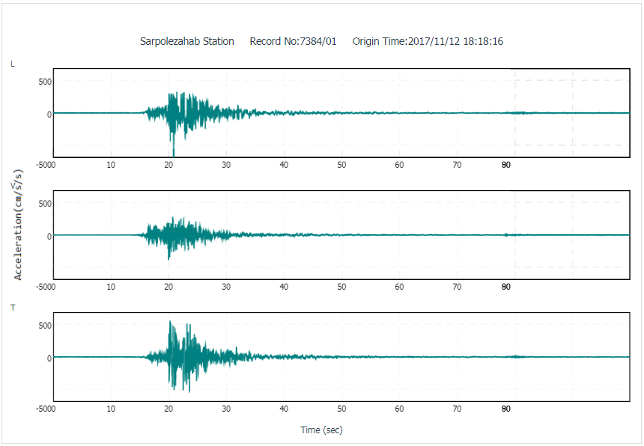
Fig 3. The maximum PGA of the 2017 Iran-Iraq earthquakerecorded at the Sarpolezahab Station. (record No:7384/01)

Based on the preliminary assessments, the maximum intensities and most of the destructions have been reported in the Sare-pole-Zahab (Fig 4) and Qasr-e- Shirin cities of Kermanshah Privince in Iran. An isoseismal map has been also provided (Fig 5) based on a field investigation by the first author. Until this day (Nov. 20), 437 people are killed and over 7,500 injured.

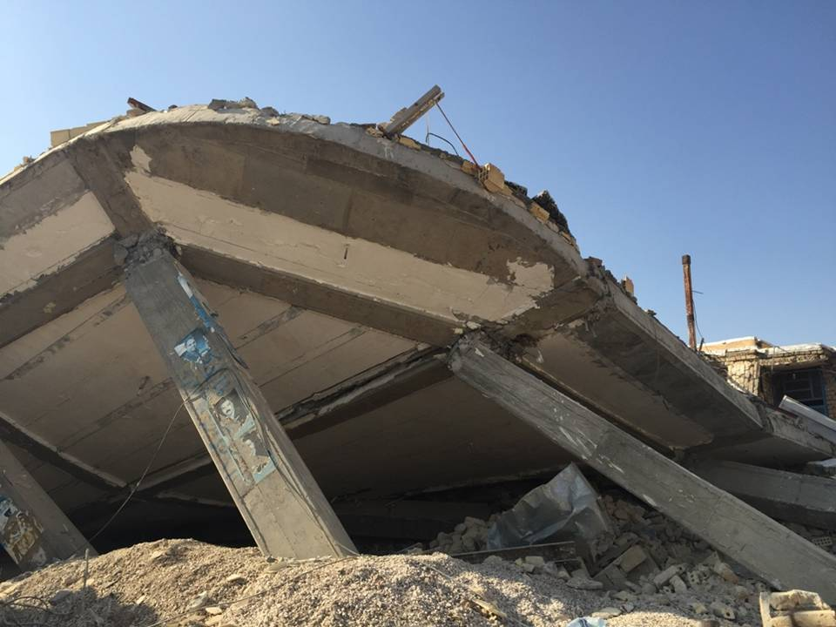

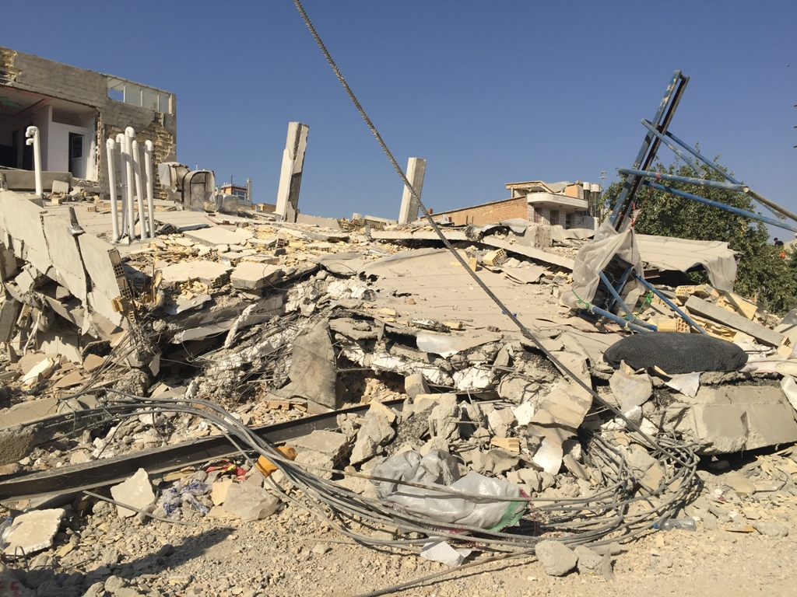
Fig 4. Collapsed buildings in Sarpol-e Zahab city

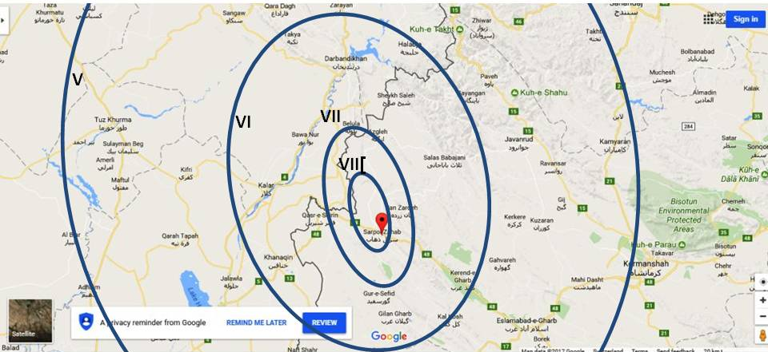

Fig 5. Iso-seismal map of the M_{w}7.3 November 12, 2017 Sarepo-e Zahab earthquake in Iran

Previous important earthquakes in this area
The seismotectonic of the affected area had been investigated in a previous study by Zare (1991) (Fig 6).

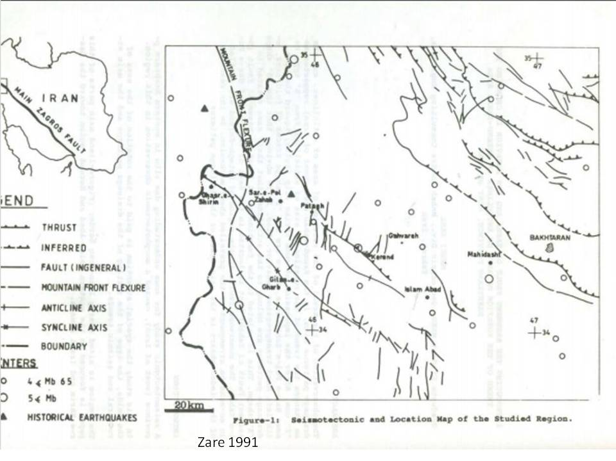
(a)
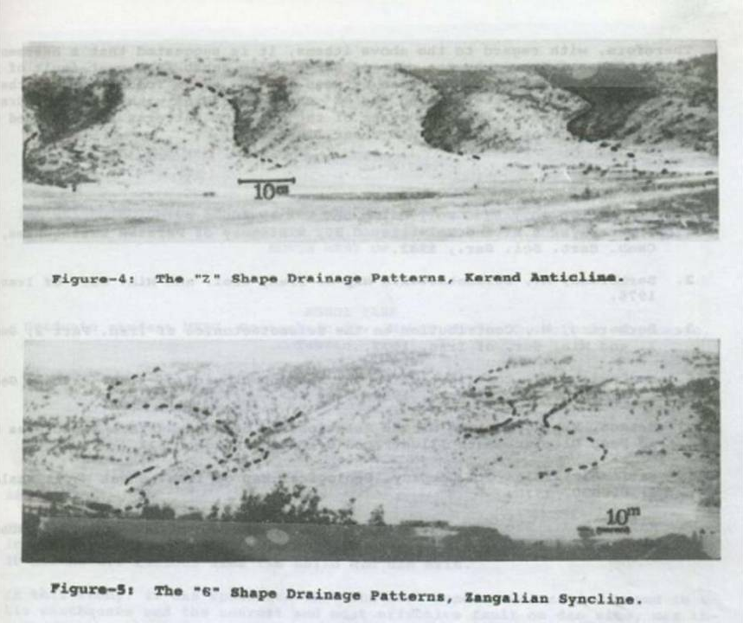
(b)

Fig 6. Seismotectonic framework of the affected area in the Zagros mountains.

Before the 2017 Sarpol-e Zahab earthquake, there has been only one major event with magnitude over 7 in this part of the Zagros Mountains which occurred in the Farsinaj region of Kermanshah province in Iran on Friday Morning, Dec. 13, 1957, at 5:15:00 a.m. local time, (1:45:00 GMT) with magnitude of Ms=7.6 and mb=6.5. The epicenter of the earthquake was located at 34.35°N and 47.67°E with about 35 km depth. A filed investigation carried out 16 years later (Ambraseys et al, 1973) shows that this earthquake caused heavy damages within an area of 2,800 square kilometers in which 1,119 people were killed and left 900 injured and 15,000 homeless. Macroseismic evidence suggests a somewhat more moderate epicentral intensity of VII+ (MMI).With the exception of a single aftershock which preceded the main earthquake by about 26 hours and which was strongly felt at Kangavar, records of the nearest seismological stations show no trace of important seismic activity in this part of the Zagros during the preceding four months. The earthquake and its numerous aftershocks destroyed or damaged beyond repair 5,000 housing units out of a total of about 9,000 (more than 55%). Most of the local type of dwellings were one-storey adobe or rubble masonry houses set in mud and covered with heavy flat roofs of tamped earth. In the larger villages there were a few two-storey adobe houses as well as some one-storey brick masonry buildings covered with Iranian jack-arches or with light roofs of galvanized iron sheets.A reconnaissance survey disclosed a fracture between Karaj Olia and Karkasar, probably of tectonic origin. As a matter of fact, there was linear topographic features in the form of terraces bearing 130°E. These fractures, which are mainly in alluvium, suggested very recent normal faulting and showed no evidences of lateral motion.

SAR Interferometry
Geodetic data, obtained by spaced-based techniques, can be used to infer the distribution of slip on a fault that has ruptured in an earthquake. Satellite images can capture co-seismic and synthetic aperture radar (SAR) interferometry can be used to detect changes in the ground surface, by removing the signal from the topography. In this earthquake event we use Differential SAR Interferometry to capture the movements produced by the 2017/11/12 earthquake in the broader area of the boundary between Iran and Iraq.. We construct interferogram by combining topographic information with SAR images by the Sentinel-1 satellite before and after the earthquake. During the stage of processing, the SAR images which were used, are on the dates 2017/10/30 and 2017/11/17 in ascending orbit. The seismic event took place at 2017/11/12so we had the opportunity to include this date into the intermediate time period between the two images. The differential interferogram produced by the SNAP software.
The map (Fig 7) of wrapped interferograms shows the fringe pattern associated with the event, where each color cycle demonstrates phase difference of [-2π], interpreted as ground deformation equal to 2.8 cm in the LOS (Line Of Sight) direction to the satellite. On the map are depicted clearly 24 to 26fringes which cover the south part of the map. At the north of the map only 4 fringes are detected. Also, we found a potential land motion between the Arabian plate and the Eurasia plate. The results of the differential interferometry show that the Arabian moved by one (1) meter and the Eurasia block moved by 10cm according to the satellite.

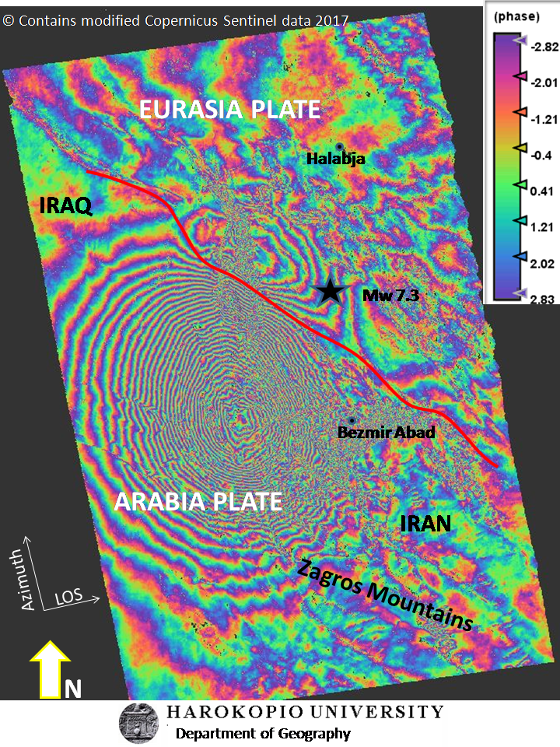
Fig 7. Ground displacements corresponding to the 2017 Iran earthquake based on SAR data

